Core Public Organization Vocabulary
Version 1.0.0

Document Metadata
Date | 2016-12-15
Rights | © 2016 European Union
Licence | ISA Open Metadata Licence v1.1, retrievable from https://joinup.ec.europa.eu/category/licence/isa-open-metadata-licence-v11
Access URL | https://joinup.ec.europa.eu/node/157143

This study was prepared for the ISA Programme by:
PwC EU Services
Disclaimer:
The views expressed in this report are purely those of the authors and may not, in any circumstances, be interpreted as stating an official position of the European Commission.
The European Commission does not guarantee the accuracy of the information included in this study, nor does it accept any responsibility for any use thereof.
Reference herein to any specific products, specifications, process, or service by trade name, trademark, manufacturer, or otherwise, does not necessarily constitute or imply its endorsement, recommendation, or favouring by the European Commission.
All care has been taken by the author to ensure that s/he has obtained, where necessary, permission to use any parts of manuscripts including illustrations, maps, and graphs, on which intellectual property rights already exist from the titular holder(s) of such rights or from her/his or their legal representative.

Contents
1. Introduction 1
1.1. Context and problem statement 1
1.2. Proposed solution 1
1.3. Scope 2
1.4. The CPOV Process and methodology 2
1.5. Structure of this document 3
2. Use cases 4
2.1. Facilitate sharing of basic data about public organizations 4
2.2. Facilitate the development of common information systems and shared services 4
2.3. Linking open organograms 5
2.4. Cross border information exchange: manage a cross-border repository of public services and organizations 5
2.5. Find a public organization by its function 6
2.6. Increase efficiencies by spotting where responsibilities and functions are duplicated or overlap 7
2.7. Keep track of the evolution of public organizations 7
2.8. Requirements 7
3. Existing Solutions 9
3.1. The W3C Organization Ontology 9
3.2. ORG-AP-OP 9
3.3. CPSV-AP 9
3.4. Existing Solution: Popolo 9
3.5. Publicbodies.org 10
3.6. Inforegister API 10
4. Core Public Organization Vocabulary 11
4.1. Class: Public Organization 11
4.1.1. Property: preferred label 12
4.1.2. Property: alternative label 13
4.1.3. Property: identifier 13
4.1.4. Property: description 13
4.1.5. Property: spatial 13
4.1.6. Property: purpose 13
4.1.7. Property: classification 14
4.1.8. Property: homepage 14
4.1.9. Property: logo 14
4.1.10. Property: hasSubOrganization (inverse: subOrganizationOf) 14
4.1.11. Property: hasUnit (inverse: unitOf) 14
4.1.12. Property: memberOf (inverse: hasMember) 15
4.1.13. Property: contactPoint 15
4.1.14. Property: address 15
4.1.15. Properties: prev/next 15
4.2. Classes: ChangeEvent, FoundationEvent 15
4.2.1. Property: resultingOrganization (inverse:resultedFrom) 16
4.2.2. Properties: originalOrganization (inverse changedBy) 16
4.2.3. Property: has formal framework (inverse changedBy) 16
4.3. Class: Formal Framework 16
4.4. Class: Address 16
4.5. Class: ContactPoint 17
4.5.1. Property: hasEmail 17
4.5.2. Property: hasTelephone 17
4.5.3. Property: openingHours 17
5. Conformance Statement 19
6. Accessibility and Multilingual Aspects 20
7. Namespaces and Prefixes 21
Appendix I: Change Log 22

List of Figures
Figure 1: Organogram of the UK Government 5
Figure 2: Link between CPSV and CPOV 6
Figure 3: Data model for the CPOV 12

List of Tables
Table 1: Process and Methodology Overview 3
Table 2: Namespaces and Prefixes 21

Introduction

Context and problem statement
The notion of a ‘public organization’ as a body that is responsible for a range of government functions is deceptively simple. However, public administrations across Europe don’t use a common and stable way of describing the fundamental characteristics of their organisations. The lack of a core vocabulary for describing a public organisation leads to interoperability issues that, among others, impede
- the discovery of public organisations within and between countries;
- the discovery of the legislation and policies that underpin, or that are created by public organisations; and
- the recognition of how public organisations interrelate with the services they provide.
The impediments listed above significantly hamper the ability of public administrations in the EU to exchange basic information about individual public organizations.

Moreover, the reality shows that almost every characteristic of public organizations is subject to change: changes in function as duties are assigned or reassigned elsewhere, changes in internal structure, changes in working methods and, although some organization's names may be ancient, others change with remarkable frequency. Such change may be the result of new legislation or policies coming into force, and tend to be particularly common immediately after elections for obvious reasons. It is therefore difficult to keep track of accurate information and yet that is precisely what's needed when considering things like purchase orders, tenders, contracts and invoices.

The need is for a common method of describing an organization and its functions that is able to capture change and yet is interoperable across domains and across borders. Datasets such as budgets, spending data, lists of contacts for services maintained and legally defined responsibilities will make references to the relevant public organization, but the value and usefulness of that data will be greatly diminished if it is out of date or otherwise inaccurate.

Proposed solution
The Core Public Organization Vocabulary (CPOV) is designed to support the exchange of basic information about individual public organizations. Using the vocabulary, almost certainly augmented with sector- or country-specific information, will facilitate the process for institutions publishing data about public organisations to
- share information G2G (government to government), G2B (government to business) and G2C (government to citizen);
- develop common information systems;
- link data from public organizations to other data sets;
- manage a cross-border repository of public services and organizations;
- enable the creation of interoperable catalogues of public organisation in Europe and beyond;
- browse public organizations by its function;
- link public service provided, budgets, and other types of resources with certain public organisations;
- keep track of the evolution of public organizations; and
- increase efficiencies by spotting duplicated or overlapping functions.
How the CPOV will help institutions to carry out the above mentioned activities is further explained in section 2.

Scope
The Core Public Organization Vocabulary is designed to describe the organization itself. Whilst the vocabulary may support links to descriptions of public services, members of staff or other resources such as relevant legislation, policies and jurisdictional coverage, it will not describe those resources in detail.

Public organizations involve elected representatives but these descriptions are out of scope for the current work but may be the focus of future work once the vocabulary is established and used.

The vocabulary is not concerned with features associated with commercial entities such as shareholdings and ownership.

Wherever possible, the CPOV will reuse existing vocabularies to avoid defining new terms. When reusing existing terms, it may define how they should be used.

In order to assure the reusability, neutrality and extensibility of the core vocabulary, specific code lists to be used as values for properties will not be included in the specification.

The CPOV Process and methodology
A Core Vocabulary is a simplified, reusable, and extensible data model that captures the fundamental characteristics of an entity in a context-neutral fashion. Well known examples of existing Core Vocabularies include the Dublin Core Metadata Set and the ISA Core Vocabularies. Such Core Vocabularies are the starting point for developing new data specifications and defining mappings between existing ones. Specifications that map to or extend such Core Vocabularies are required to guarantee a level of cross-domain and cross-border interoperability that can be attained by public administrations.

The work has been conducted according to the ISA process and methodology for developing Core Vocabularies. The process and methodology provide guidance in two domains. First, the process describes how consensus is reached among stakeholders and domain experts so that the vocabulary meets its goals. Second, the methodology describes how the core vocabulary is specified following best practices for selecting, reusing, developing and presenting concepts. Table 1 provides an overview of the steps in the process and methodology. In case amendments to the CPOV are requested after its publication, the change management, release and publication process for structural metadata specifications developed by the ISA Programme will be followed.
Table 1: Process and Methodology Overview
Process  Reaching consensus | Methodology  Developing a specification
- Identify stakeholders  - Form working group  - Identify chair & co-chair  - Identify editors  - Form review group  - Secure IPR  - Establish working environment and culture  - Publish drafts  - Review drafts  - Publish last call working draft  - Review last call working draft  - Gather evidence of acceptance  - Submit for endorsement  - Endorse | - Identify a meaningful set of Core Concepts  - Research and review existing solutions  - Research existing data and services  - Use cases  - Requirements  - Terminology and conceptual data model  - Naming conventions  - Identifier conventions  - The namespace document  - Quality Assurance & Conformance Criteria

Structure of this document
This document consists of the following sections.
- Section 2 defines the main use cases that drive the specification of CPOV, as well as the specific requirements.
- Section 3 gives a very brief summary of a number of existing initiatives in this area.
- The classes and properties defined for the CPOV are presented in section 4.
- Sections 5 and 6 provide the Conformance Statement for the CPOV and review the accessibility and multilingual issues.
- Finally section 7 lists the prefixes and namespaces used throughout the document and section 0 provides a change log for comparison with previous drafts of this document.

Use cases
The Core Public Organization Vocabulary (CPOV) is designed to meet specific needs of public administrations, businesses and citizens across the European Union and beyond. These needs are described in the use cases below.

Facilitate sharing of basic data about public organizations
Information sharing across organizations is often hampered by the lack of semantic agreements. Common data standards, such as Core Vocabularies, help public administrations to overcome the semantic barrier to information sharing. The CPOV is designed to make the exchange of basic information about public organizations easier. By using the vocabulary, administrations publishing data about their organization will enable
- easier discovery of their organization within and between countries;
- easier identification of how organizations interrelate;
- improved understanding of provided information because of common definitions; and
- easier comparison of similar organizations across sectors or countries.

 | The CPOV will facilitate the publication and sharing of basic data about public organizations in G2G (Government-to-Government), G2B (Government-to-Business) and G2C (Government-to-Citizen) scenarios.

Facilitate the development of common information systems and shared services
A common standard for describing public organizations, could support the development of common information systems and shared horizontal services in which public organizations are referred, such as
- A central HR system in which government employees are linked to different public organizations, posts, contact details and salaries;
- A facilities management system used across public organizations linking physical resources such as buildings and office equipment to public organizations and their staff; and
- An e-Invoicing system in which the data quality can be improved by modelling and uniquely identifying public organizations to whom invoices are addressed.

 | The use of existing data models for the development of common information systems and shared services facilitates the development of those systems/services and improves their interoperability.

Linking open organograms
Many Public Organizations across the European Union publish their organograms online. Often, these organograms are published in non-machine-readable formats such as images or PDFs, limiting the reuse potential of organizational data. Publishing data in machine-readable formats enables public organizations and third parties to build tools that increase the usability and understandability of the data. Examples of publishing organograms as machine-readable data include the UK organogram of public staff and the Italian Index of Public Administrations.
Figure 1: Organogram of the UK Government
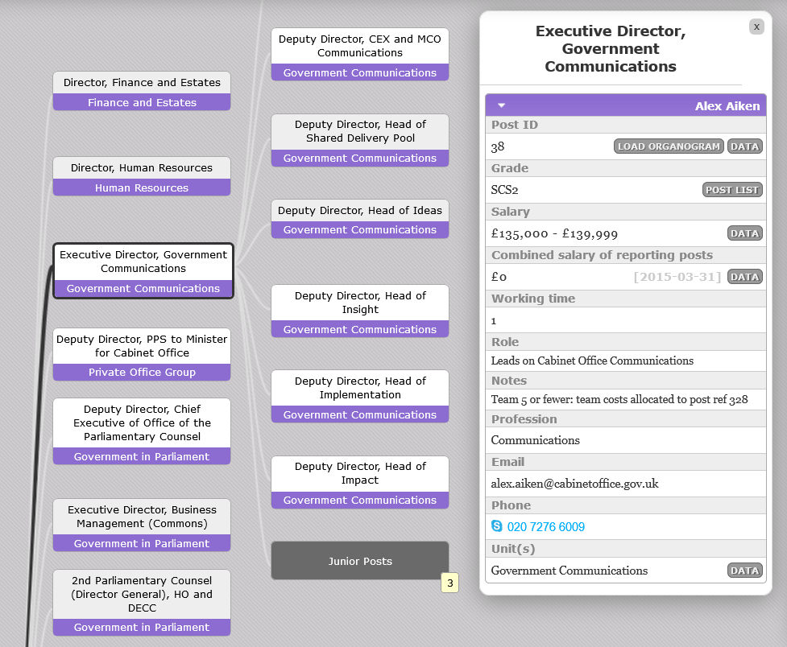 | The organogram of the UK government is made available in the machine-readable RDF format, which allows the government to present its organogram using an intuitive, open-source tool. The data is structured following an RDF vocabulary consisting of both reused as minted terms.

By publishing organograms in linked open data formats, such as RDF, it becomes possible to link data from different sources. For example, the Salary data in the British organogram can be linked to high value data sets such as the British annual budget. Moreover, if organograms are structured following a common data model, it would be possible to link organograms across organizations and countries.

 | The Core Public Organization Vocabulary has the potential to link organograms to each other and to high value data sets.

Cross border information exchange: manage a cross-border repository of public services and organizations
A use case for the development of the Core Public Service Vocabulary (CPSV), which was developed by the ISA Programme, is the management of a portfolio of public services. The CPSV was identified as one of the key elements for the development of such a repository.
“In most countries, the ownership and management of public services is split amongst different public administrations leading to different ways of managing their lifecycle. This makes it difficult to have a complete view of the public services offered within the context of a Member State, and to have a holistic approach for their management and the way the public services are grouped into business events.”

The CPSV addresses the need for public administrations to describe their services and events in a common way. The CPOV has the potential to become a second key element of such a repository, providing the ability to link public services to public organizations, hence defining which organization has the authority over specific public services.
Figure 2: Link between CPSV and CPOV
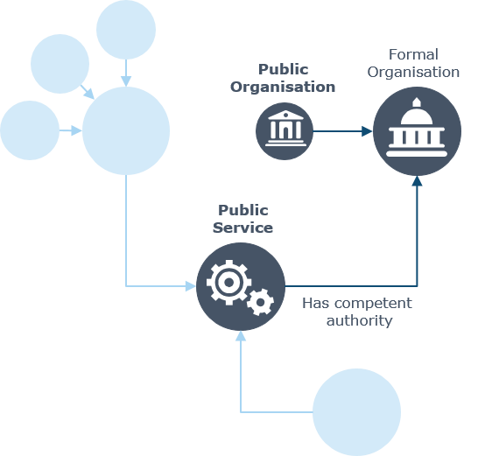 | The Core Public Service Vocabulary Application Profile for Public Administrations in Europe (CPSV-AP) specified the relationship “has competent authority” as a mandatory element of the data model. The relationships indicates how a public service and a formal organization, such as a public organization, are related.

 | Public service and organization portfolio management allows public administration to apply a holistic and systematic management across authorities. The CPSV and the CPOV are important assets for enabling cross-country interoperability in these area.

Find a public organization by its function
When looking across borders and across sectors, often it is the functions performed by an organization, rather than the organization itself, that is the primary focus. For example, the function of improving ICT use across government may be the function of a specific ministry (such as MAREG in Greece), a government agency (such as Italy's AgID), part of the ministry of finance (such as in Finland) or the office of the Prime Minister (such as in the UK and Austria). Someone searching for contacts with people in other countries or regions who perform similar functions to their own will be able to use the CPOV to discover the organizations responsible for specific functions or areas of government. This complements, but does not replace, the notion of a public service directory.
 | The public organization portfolio facilitates discovery of which public authorities and departments are responsible for given areas of governmental functions.

Increase efficiencies by spotting where responsibilities and functions are duplicated or overlap
The public sector is highly complex. It is very difficult to maintain a clear overview of how different departments and agencies interrelate and where functions and responsibilities overlap. The CPOV, with its links between organizations, their departments and their responsibilities, structures the different relations and thereby spot similarities, duplications of effort or gaps in the system. Comparisons can also be made across borders so that potential efficiencies can be more easily identified. Visual representation of these links become possible to further facilitate oversight and coordination.

 | A visualisation of the structure of the public sector, particularly when compared with similar governments elsewhere in Europe, offers the potential for significant efficiency gains.

Keep track of the evolution of public organizations
The structure and responsibilities of public organizations are prone to change, e.g. following elections. The CPOV allows to track these changes over time documenting the historic evolution of organisational structures.

 | The CPOV allows stakeholders to track the frequent changes in structure and responsibilities of public organizations.

Requirements
The use cases set out above give rise to the following requirements:

R1 Basic facts about the organization must be recorded such as its name, contact point(s), address(es) etc.

R2 The relationship between an organization and its constituent departments or subsidiaries must be captured.

R3 The description must be tied to a time, either the current time, i.e. the description that applies today, or a historical period, ideally with a start and end date with references to relevant legislation.

R4 Descriptions must persist and be readily referenced beyond the life of the current organization.

R5 The vocabulary must support descriptions of the responsibilities conferred and the functions performed by an organization.

R6 It must be possible to recognise different organizations by their function/responsibilities.

Use case 2.3 strongly suggests the requirement that it should be possible to generate organograms, that is, organization charts, from data created using the CPOV. The Working Group resolved that details of posts within a public organization and the people holding those posts was out of scope for the current work. Nevertheless, the vocabulary should not prevent or hinder the addition of such information.

Existing Solutions
The need for a systematised way to refer to and describe public organizations is not new. Several solutions already exist, some of which are listed in this section.

The W3C Organization Ontology
Initially developed in 2010 for the UK government, the Organization Ontology became a W3C standard in January 2014 and has been widely used elsewhere. It can be seen as meeting all the requirements, however, the current work assess this view and makes additions and recommendations on how it can be used in particular, for properties such as org:classification and org:purpose.

ORG-AP-OP
The Application Profile of the Organization Ontology developed by the Publications Office of the European Union underpins their popular whoiswho service. That service provides contact information for staff across the European Institutions and so is focussed on people and the roles they play. Such a service is beyond the scope of the current work although it bears a clear relation in terms of describing the actual institutions. The CPOV should therefore be consistent with the ORG-AP-OP, i.e. the CPOV should not require changes to be made to the ORG-AP-OP.

CPSV-AP
The Core Public Service Vocabulary and its Application Profile (CPSV-AP) was developed by the ISA Programme of the EU in 2015. The data model aims to describe public services and group them in business events. The CPSV-AP defines a number of terms that are closely related to the CPOV. For example, the administrative level, the type of organization, and its home page. At the time of writing it is clear that the ongoing work to revise the CPSV-AP will defer to the CPOV for describing public organizations that operate services. For more information on how the CPSV-AP integrates with the CPOV, please refer to section 2.4.

Existing Solution: Popolo
The Popolo Project created a vocabulary for describing organizations that reuses a lot of the terms from the ORG Ontology but adds in some new ones. As well as providing serialisations in RDF, it also offers a JSON schema that introduces a few minor tweaks to some of the term names. This means that the same data serialised as JSON and RDF will have different names for, for example, 'seeAlso.' The Popolo vocabulary does not model change events as such but does record previous names, with start and end dates. This is similar to the approach taken in the data behind the Publications Office's whoiswho tool.

Publicbodies.org
Publicbodies.org is an Open Knowledge Labs project that aims to aggregate data on public organizations around the world, making them searchable in a single database on the publicbodies.org website. The tools and relevant open source code are hosted on Github, as is the data submitted by volunteers.

The project uses a simple tabular data model, which is under constant evolutionary change.

Inforegister API
The Inforegister API is a commercial project of Register OÜ that extends the W3C Organization ontology such that it can be used for exposing organization data via its linked data API.

The main extensions include a vocabulary for modelling representation rights of members of organizations (e.g. who, and under which conditions, is eligible to sign a contract on behalf of an organization), VAT group memberships, classifiers for organization statuses and roles of representatives.

Core Public Organization Vocabulary
The data model for the CPOV is shown in Figure 3. It is largely a subset (profile) of the Organization Ontology covering the basic description of an organization and the purpose(s) that it exists to serve. It defines two new classes of its own and makes use of other vocabularies in addition to ORG. Prefixes used for RDF properties are listed in section 7.

Class: Public Organization
The Public Organization class represents the organization. One organization may comprise several sub-organizations and any organization may have one or more organizational units. Each of these is described using the same properties and relationships.

Following substantial discussion, the CPOV provides a very general definition of a Public Organization as: any organization that is defined as being part of the public sector by a legal framework at any level.

This is consistent with the more detailed definition of a “public sector body” as given in the directive PSI Directive: “the State, regional or local authorities, bodies governed by public law and associations formed by one or several such authorities or one or several such bodies governed by public law”. It further defines a body governed by public law as any body “(a) established for the specific purpose of meeting needs in the general interest, not having an industrial or commercial character; and (b) having legal personality; and (c) financed, for the most part by the State, or regional or local authorities, or other bodies governed by public law; or subject to management supervision by those bodies; or having an administrative, managerial or supervisory board, more than half of whose members are appointed by the State, regional or local authorities or by other bodies governed by public law”.

In the RDF release of the CPOV, this class is bound to cv:PublicOrganization which is defined as a sub class of org:Organization. In some cases, albeit rare ones, a Public Organization may not be a legal entity, such as the Flemish Information Agency being recognised as a Public Organization, but not being a legal entity. Furthermore, the definition is considered sufficiently distinct that it is inappropriate to define cv:PublicOrganization as a sub class of org:FormalOrganization which may otherwise be considered natural. It is noteworthy in that context that cv:PublicOrganization is not defined as disjoint with org:FormalOrganization or any other class from any vocabulary.
Figure 3: Data model for the CPOV
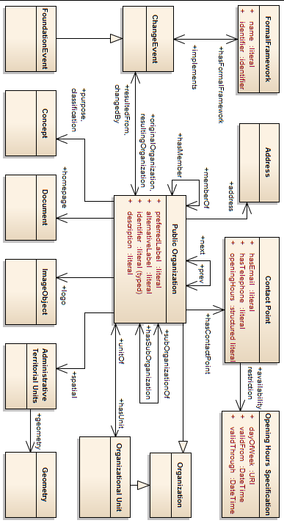

Property: preferred label
As defined in the ORG Ontology, a preferred label is used to provide the primary, legally recognised name of the organization. An organization may only have one such name in any given language. Primary names may be provided in multiple languages with multiple instances of the preferred label property.

In the RDF release of the CPOV, this property is bound to skos:prefLabel.

Property: alternative label
In line with ORG and SKOS itself, an organization may have any number of alternative or informal names, irrespective of language.

In the RDF release of the CPOV, this property is bound to skos:altLabel.

Property: identifier
Many organizations are referred to by an acronym or some other identifier. For example, among the EU institutions, the ECB is the identifier for the European Central Bank, OLAF for the European Anti-Fraud Office, and so on. These are formally recognised by the European Commission which provides a list of such acronyms. Analogous lists should be used in other contexts.

In the RDF release of the CPOV, this property is bound to org:identifier.

Property: description
This property provides a textual description of the organization.

In the RDF release of the CPOV, this property is bound to dcterms:description.

Property: spatial
This property links an organization to the administrative region(s) that it covers. The value of the properly should be the URI of the region as defined in an authoritative list of regions. In Europe, this is likely to be the Administrative Territorial Units Named Authority List maintained by the Publications Office's Metadata Registry.

In the RDF release of the CPOV, this property is bound to dcterms:spatial.

The ATU list does not include a geometry. That is, the territory is only identified by its name not its spatial coordinates. This is likely to be the case for similar lists. If geometries are available for the Public Organization's territory, they can be linked from the territorial unit using the Location Core Vocabulary's locn:geometry property.

Property: purpose
This property links an organization to its function(s) which are expressed as a SKOS Concept Scheme. The ORG ontology suggests that this property can also be thought of as meaning 'remit' or 'responsibility.' Ideally this will link to a COFOG code but where this isn't possible or appropriate, other controlled vocabularies may be used.

In the RDF release of the CPOV, this property is bound to org:purpose.

Property: classification
This property links an organization to a SKOS Concept that provides a classification. As an example, the Publications Office of the European Union provides a Named Authority list of Organization Types which is appropriate for European institutions. Other classification schemes should be used at other levels of public organization.

In the RDF release of the CPOV, this property is bound to org:classification.

Property: homepage
A property to link an organization to its website homepage. The value of this property is a URL irrespective of the serialisation of the data.

In the RDF release of the CPOV, this property is bound to foaf:homepage.

Property: logo
A property to link an organization to its logo. The value of this property can simply be the URL of the logo but it is better for developers if it links to an object that provides the URL of the image and essential metadata about it, notably its dimensions.

In the RDF release of the CPOV, this property is bound to schema:logo which takes either a URL or a schema:ImageObject as its value.

Property: hasSubOrganization (inverse: subOrganizationOf)
Public Organizations are often large and complex and may be a collection of smaller organizations, each of which has a specific identity that may be legally defined. The hasSubOrganization and subOrganizationOf properties express the relationships between organizations in a hierarchical structure. In contrast, hasUnit and unitOf are used to link to operational departments within an organization that may not generally exist in their own right.

In the RDF release of the CPOV, hasSubOrganization is bound to org:hasSubOrganization and subOrganizationOf is bound to org:subOrganizationOf.

Property: hasUnit (inverse: unitOf)
Organizations typically comprise many departments, units, teams etc. Each of these is modelled in the CPOV as a unit that is linked from the parent organization with hasUnit and to the parent with unitOf. An Organizational Unit is a sub class of Organization but conceptually does not exist in its own right. This is in contrast to a sub organization that, although part of the larger organization, may be legally distinct or otherwise enjoy a degree of autonomy.

In the RDF release of the CPOV, hasUnit is bound to org:hasUnit and unitOf is bound to org:unitOf.

Property: memberOf (inverse: hasMember)
One organization may be a member of another without being a sub organization, i.e. they are independent entities. These properties allow such relationships to be captured.

The memberOf and hasMember properties are very simple and don't support statements describing the nature of the membership. The W3C Organization Ontology provides both this simple method and a more sophisticated model that does make it possible to, for example, provide information about the period of time in which one organization was a member of another, the level of membership etc. That more sophisticated model should be used where necessary and may be used in addition to the simple memberOf/hasMember properties.

In the RDF release of the CPOV, memberOf and hasMember are bound to org:memberOf and org:hasMember respectively.

Property: contactPoint
The contact point property links to a Contact Point (section 4.5) that provides contact information, in particular a phone number and e-mail address. Other contact methods may be included, including online contact information, but this is conceptually distinct from the organization's homepage (4.1.8) that may or may not provide contact information.

In the RDF release of the CPOV, this property is bound to schema:contactPoint.

Property: address
A property to link a public organization to its address. For consistency with INSPIRE, the Location Core Vocabulary's Address class should be used.

In the RDF release of the CPOV, address is bound to locn:address.

Properties: prev/next
In some cases, it is necessary to be able to create an ordered sequence of organizations that precede and succeed each other. To support this, the CPOV includes the well-known relationships of previous and next to allow such sequences to be captured and computed.

In the RDF release of the CPOV, these properties are bound to xhv:prev and xhv:next.

Classes: ChangeEvent, FoundationEvent
Public organizations are formed and changed in response to events. This may be the result of new legislation, new policies, taking on new obligations etc. The CPOV captures this in its Change Event class but recognises the specific case of an organization's foundation as being sufficiently distinct to require a sub class of Change Event.

In the RDF release of the CPOV, ChangeEvent is bound to org:ChangeEvent, FoundationEvent is in the CPOV's own namespace, i.e. cv:FoundationEvent.

Property: resultingOrganization (inverse:resultedFrom)
This property links a Change Event or a Foundation Event to the organization that resulted from it.

In the RDF release of the CPOV, these properties are bound to org:resultingOrganization and org:resultedFrom.

Properties: originalOrganization (inverse changedBy)
The originalOrganization property links a Change Event to the organization that existed before the change. Although the Foundation Event class is defined as a sub class of Change Event, it is inappropriate to use the originalOrganization property with the Foundation Event class.

In the RDF release of the CPOV, these properties are bound to org:originalOrganization and org:changedBy.

Property: has formal framework (inverse changedBy)
hasFormalFramework links a Change Event or Foundation Event to a piece of legislation or a policy document that prompted the change. These concepts and properties are defined in the Core Public Service Vocabulary (CPSV).

In the RDF release of the CPOV, these properties are bound to cpsv:hasFormalFramework and cpsv:implements.

Class: Formal Framework
This class and its properties are defined in the Core Public Service Vocabulary and may represent legislation or official policy that leads to a change event, including the establishment of the organization.

In the RDF release of the CPOV, this class is bound to cpsv:FormalFramework.

Class: Address
The Address class is defined in the Location Core Vocabulary. Its properties are closely bound to the INSPIRE data model for addresses. In particular, it separates out building names and numbers from the name of the thoroughfare. This is in contrast to VCard which conflates them into 'street address.' The Location Core Vocabulary does, however, borrow the fullAddress property from VCard as a means of providing the full text of the address as a literal.

The RDF release of the CPOV, this class is bound to locn:Address.

Class: ContactPoint
A class representing a point of contact for the organization. The Core Public Organization Vocabulary defines properties for telephone number, e-mail address and opening hours although it is noteworthy that the class is based on schema.org’s ContactPoint class (http://schema.org/ContactPoint) that has additional properties that some implementations may find useful.

The RDF release of the CPOV, this class is bound to schema:ContactPoint.

Property: hasEmail
A property through which an e-mail address for the Public Organisation, or a representative of it, can be contacted.

In the RDF release of the CPOV, this property is bound to schema:email.

Property: hasTelephone
A property through which a phone number for the Public Organization, or a representative of it, can be contacted.

In the RDF release of the CPOV, this property is bound to schema:telephone.

Property: openingHours
The value of this property is structured text that gives the hours at which the contact point is normally available. Days are specified using two-letter combinations: Mo, Tu, We, Th, Fr, Sa, Su. For example, if the contact point is open Monday-Friday, 9 -5, the value of the openingHours property would be Mo-Fr 09:00-17:00. If the Contact Point is only available on Tuesday and Thursday between 6 and 8pm, the value would be Tu,Th 16:00-20:00.

The RDF release of the CPOV, this class is bound to schema:openingHours. At the time of writing, the domain of schema:openingHours does not include ContactPoint, however, this is expected to change in the near future, prompted by the CPOV.

Property: availabilityRestriction
The availabilityRestriction property links a Contact Point to details of specific details of its opening hours that override the general case. See section 4.6 for details.

In the RDF release of the CPOV, this property is bound to schema:hoursAvailable.

Class: Opening Hours Specification
The Core Public Organization Vocabulary makes full use of schema.org’s openingHours property (section 4.5.3) to provide details of regular operations. The Opening Hours Specification class can be used to provide details of exceptional circumstances, such as being closed on public holidays, thus:

ex:PublicHolidayClosed a schema:OpeningHoursSpecification;
schema:dayOfWeek <http://schema.org/PublicHoliday>.

Note that the property schema:opens is not used, therefore the contact point is closed. More specific closures can be indicated by including the schema:validFrom and schema:validThrough properties, for example:

ex:ChristmasClosed a schema:OpeningHoursSpecification;
schema:validFrom “2016-12-24T012:00Z”;
schema:validThrough “2017-01-02T09:00Z”.

Conformance Statement
A data exchange, however that exchange occurs, is conformant with the Core Public Organization Vocabulary if:
- it uses the terms (classes and properties) in a way consistent with their semantics as declared in this specification;
- it does not use terms from other vocabularies instead of ones defined in this vocabulary that could reasonably be used.

A conforming data interchange:
- may include terms from other vocabularies;
- may use only a subset of Core Public Organization Vocabulary terms.

A CPOV application profile is a specification for data interchange that adds additional constraints. Such additional constraints in a profile may include:
- a minimum set of required terms;
- classes and properties for additional terms not covered in the Core Public Organization Vocabulary;
- controlled vocabularies or URI sets as acceptable values for properties.

The Core Public Organization Vocabulary is technology-neutral and a publisher may use any of the terms defined in this document encoded in any technology although RDF and XML are preferred.

Accessibility and Multilingual Aspects
The CPOV can operate in any language as:
- The values of all properties with a datatype “Literal” may exist in multiple languages. The property may have multiple instances that are tagged with a language identifier for each language in which the value for that property exists.
- The specification strongly encourages the use of URIs as identifiers which are 'dumb strings.' Although they clearly make use of English words, they do not convey those words as data - that is done by the human-readable labels which can be multilingual.
- The acronym URI is used throughout the document due to widespread familiarity. However, Internationalised Resource Identifiers (IRIs) are equally usable, and these can use any character in any script.
Translations of the labels used in the various terms can readily be added to the schema (please contact the working group if you can help with this).

Namespaces and Prefixes
This specification uses the following prefixes and namespaces.

Table 2: Namespaces and Prefixes
Prefix | Namespace
cpov | A URI for Core Vocabularies on the http://data.europa.eu domain will be assigned in the coming months.
cpsv
org | http://www.w3.org/ns/org#
dcterms | http://purl.org/dc/terms/
skos | http://www.w3.org/2004/02/skos/core#
schema | http://schema.org/
locn | http://www.w3.org/ns/locn#
foaf | http://xmlns.com/foaf/0.1/
xhv | http://www.w3.org/1999/xhtml/vocab#

Appendix I: Change Log
Changes since version 2:
- Revision of the data model to include membership relations
- Inclusion of the Address class from the LOCN vocabulary in line with discussion on Joinup.
- Addition of Foundation Event as sub class of Change Event.
- Addition of Contact Point
- Completion of listing of all terms in the CPOV except properties of Formal Framework and Address which are defined elsewhere.
- Requirements moved to use cases section; requirement to support organograms removed and an explanation provided. The relevant use case was retained however.
- The Popolo Project created a vocabulary for describing organizations that reuses a lot of the terms from the ORG Ontology but adds in some new ones. As well as providing serialisations in RDF, it also offers a JSON schema that introduces a few minor tweaks to some of the term names. This means that the same data serialised as JSON and RDF will have different names for, for example, 'seeAlso.' The Popolo vocabulary does not model change events as such but does record previous names, with start and end dates. This is similar to the approach taken in the data behind the Publications Office's whoiswho tool. added as an existing solution.

http://dublincore.org/documents/dcmi-terms/
https://joinup.ec.europa.eu/asset/core_vocabularies/description
https://joinup.ec.europa.eu/catalogue/asset_release/process-and-methodology-developing-core-vocabularies
Dekkers, M., Goedertier, S., Loutas, N., Wyns, B., & Kotoglou, S. (2015). D02.02.2: Description of a change management release and publication process for structural metadata specifications developed by the ISA Programme. Brussels: European Commission - ISA Programme.
https://data.gov.uk/organogram/
IPA: http://spcdata.digitpa.gov.it/dataIPA.html
https://joinup.ec.europa.eu/asset/core_public_service/asset_release/core-public-service-vocabulary-0
https://joinup.ec.europa.eu/node/148999
https://www.w3.org/TR/vocab-org
https://www.w3.org/2011/gld/wiki/ORG_Implementations
http://whoiswho.europa.eu
https://joinup.ec.europa.eu/asset/cpsv-ap/issue/reflecting-modelling-public-organisation-core-public-service-vocabulary
http://www.popoloproject.com/specs/organization.html
http://europa.eu/whoiswho/
http://okfnlabs.org/
http://github.com/okfn/publicbodies/
http://data.okfn.org/data/okfn/public-bodies
See https://developers.ir.ee/graph-api#get-all-data-of-an-organization for an example
https://joinup.ec.europa.eu/asset/cpov/issue/definition-public-organisation
http://eur-lex.europa.eu/legal-content/EN/TXT/HTML/?uri=CELEX:32003L0098&qid=1456507093478&from=EN
http://ec.europa.eu/eurostat/ramon/cybernews/abbreviations.htm
http://publications.europa.eu/mdr/authority/atu/
www.w3.org/ns/locn#locn:geometry
http://publications.europa.eu/mdr/authority/organization-type/index.html
https://www.w3.org/TR/vocab-org/#membership-roles-posts-and-reporting
https://www.w3.org/ns/locn
https://github.com/schemaorg/schemaorg/issues/1444
http://schema.org/OpeningHoursSpecification
http://www.ietf.org/rfc/rfc3987.txt
https://joinup.ec.europa.eu/node/148999/

